COMM2676
Contemporary Approaches to Media & Communication

Project Report

Team Name: Fern, Will, Boris, Romy

Project:

Showcase Website URL:

Tutor: Ella

Contents
Project Report 3
1. Executive Summary 3
2. Team Introduction & Roles 3
3. Purpose 3
4. Key Terminology 3
5. Context & Situational Analysis 3
6. Research Insights 3
7. Stakeholders 4
8. Communication Problem/Gap/Opportunity 4
9. Target Audience/s 4
10. Message 4
11. Communication Solution 4
12. Point of Difference 5
13. Communication Channels 5
14. Project Timeline 5
15. References 5

Appendix A: Background Documentation 7
Project Ideation 7
Research Documentation 7
Team Work Documentation 7
Reflective Responses 7
Presentation Materials 7

Appendix B: Creative Communication Campaign/Strategy/Plan 8
Issue 8
Goal 8
Target Audience/s 8
Communication Methods 8
Objectives 8

Appendix C: Project Artefacts 9
Communication Campaign/Strategy Artefacts 9
Media Artefact/Story 9
Journalism Story Pitches 9
Local 9
National 9
International 9
Sample News Article 9

Project Report

Green means its done but need review
Yellow means it needs more work
Red means it needs to be complete

Executive Summary

How are attitudes to industry automation changing and affecting global changes? The following report looks into how the fear of robots replacing human jobs is leading to societal distrust of automation and avoidance of its use. Throughout history humans have constantly been looking for ways to increase production efficiencies, replacing jobs.

The replacement of jobs with automation is led to fear, of both their livelihood and careers. Translating this fear into the 21st Century, many media outlets as well as labour groups have seen automated production methods as a threat. Many people reject the idea of everyday automated, including automated transport. This form of short-term thinking is leading to many people to avoid using robots, and a societal acceptance of less efficient methods. If the distrust continues technological advance may be stuck, refusing to advance and make human life better in the long run. As many media organisations thrive off fear mongering we aim to provide rational debate regarding automation and to an extent artificial intelligence (AI).

Communication strategies will be implemented highlighting the overall benefits to more efficient production as well as mitigating any threats about the ethics of robotics, especially respecting job losses. To create lasting benefits to our societies advancing technologies must be embraced through the discussion of key stakeholders' interests and demonstration of its benefits.

Team Introduction & Role

Will: Will is primarily tasked with key research and website development. Coordinating with the team he will both assist in overall project concept development as well as timeline coordination. Will has a key task in visual development and transfer to the website and other digital forms.

Fern: Fernis responsible for key strategizing for the communications plan. She is also responsible for all communications outputs and how they correspond with key project objectives. Fern also ensures all stakeholders are sufficiently reached and their issues satisfied.

Boris: Boris is in oversight of all written materials. Coordinating with the research team he must sufficiently reflect group optupts in verbal means. Boris then coordinates with the visual team to ensure all project artifacts correspond. Boris also partakes in key project concept development and planning.

Romy: Romy is responsible for the major project insights. Romy must coordinate these insights with the team to provide visual and written equivalents. Romy is also responsible for infographics, ensuring that they indeed represent key research findings.

Purpose F

The project is aimed at changing public and stakeholder perceptions to the use of automation in their daily lives. Changing mindsets will allow for more efficient automation policies that would benefit technological development. This will encourage long term thinking and overall societal benefit.

To change mindset
- Technology should be viewed as as a opportunities for societal growth and to refine one's own skills.

- Young are worried about their future prospects in a changing industry. Aspire them to embrace technology rather than be luddited against it.

Key Terminology

Ethical automation tool kit. A holistic process used to address public understanding and address conscious and unconscious biases of automation. In involves the following:
- Human rights - The use of machine must benefit humanity and society
- Improve wellbeing - Autonomous machines must not harm human health and wellbeing
- Accountability - A human must be responsible for operation or error.
- Transparency - Clear intended use of the artificial intelligence
- React to misuse

Humans in the loop. Ensures that machines objectives align with that various stakeholders - also ensuring accountability.

Context & Situational Analysis

Since the invention of farming we as humans have continued to develop more efficient ways of producing. In parallel to these greater production possibilities is lost jobs of humans, replaced by automation and recently AI. With more efficient systems inventors have more time to invent and specializations are created, compounding the effect.

Most recently it is intelligent robotics (AI) that are taking the forefront if discourse and social awareness. Many industry leaders and scientists are concerned that more complex human jobs are being completely replaced, no longer just enhancing human abilities. Questions about automation was brought up over a new Amazon recruitment system. The computer program was able to sieve through applicants resume and video’s, looking at key words, educational pathways and employee performance. Following the initial data the software automatically produced a scorecard, rating the worker and making previously human recruitment officers obsolete. Though creating a more efficient recruitment process for Amazon the system has been brought into question of its overall ethics. The software not only replaces human jobs but supposedly held inherent human biases from the programmers, and exaggerated by the software. As a result the recruitment software the often placing candidates lower according to their gender and other demographic factors. In response many feminist and other rights groups challenged Amazon. The programing of the bot resulted in the technology developing a bias rather than the “deliberately” discriminating against group. The story was picked up by the media, generating poor coverage at Amazon's recruitment standards and the reliability of automation and AI.

Currently and with further advancements in technology the majority of media portrait automation as a threat to humans. Skeptics state that intelligent automation (AI) may take up to half of all human jobs by 2055, with a 20 year margin of error source. Many of these jobs tend to be lower income and male, most prominently truck drivers who may become totally obsolete with automated transport. Despite replacing jobs automated vehicles and machines with human contact come under another wave of scrutiny. In 2018 an incident in Arizona USA resulted in the killing of a pedestrian by an automated car owned by Uber. Currently the law states that “humans must be blamed”, but i still led to large backlash from the public about the ethics of robotics in contact with humans. The accident also led to many stakeholders, including shareholders leaving many technology companies with fears brought up by robotic independence.

The situation of robotics is no longer black and white. With the growing ability for automated machines and AI to self control has led to questions regarding their place in the world. Many supporters or technology have claimed the benefits of technology. Through a death did occur self driving cars have a much lower chance of fatal accidents compared to their human counterparts. Supportive media also elaborates that robots without human interference will be far safer and more efficient. For example, with humans on the road self-driving cars will always have to drive slower to take into account the possibility of human error. In contrast many media organisation portrait robotics as a bad thing. Most recently in Australia the closure of the Ford factory has led to upset as many jobs were replaced by an automated assembly line. The media's portrayal is generally short-term, the immediate job loss rather than the overall societal benefit of cheaper goods. Similarly, automated checkouts have led to far greater efficiencies in out high-trust societies, but have led to many low skilled and low paid job losses.

Changing industries as a result of robotics and AI have led many people to be sceptical and even fearful of technological advancements. The media's short term, views focused scare campaign of short term thinking has allowed even greater support for luddites. Though the industry is still developing mostly unopposed many are fearful that significant job losses in a short span of time, such as truck drivers, may lead to significant social unrest. The campaign proposed is aimed at tackling this problem, encouraging social and in effect government and industrial support for technologies. Through jobs may be lost in the short term, society will greatly benefit overall.

- The employment sector is not just under threat of replacement, but the intrusion of employee selection bias
  - Amazon introduced it’s automated recruiting systems which sieves through applicant resumes and video’s. It analysed recordings, keywords, education pathways and employee performance before concluding a numerical score/ranking.
  - However Amazon’s system failed to eliminate pre-existing human biases, often placing candidates lower according to their gender. This caused outrage amongst feminists groups and Amazon employees.
  - Media coverage of the incidence was negative demonstrated by this article.
(https://www.reuters.com/article/us-amazon-com-jobs-automation-insight/amazon-scraps-secret-ai-recruiting-tool-that-showed-bias-against-women-idUSKCN1MK08G)
- The reason why amazon uses AI to recruit its employees is to eliminate human bias’s when it comes to employment

- Currently, the media portrays the media as a threat. Skeptics argue that AI may take half of the jobs by 2055 with a 20 year margin or error. These reports are relatively under supported by research.
- A 2018 incident in Arizona USA, involved an automated car owned by Uber killing a pedestrian. The car was owned by Uber, operated by a human driver, which is operated by various components of technology manufactured by many different technology companies.
- The situation is no longer back or white, as the issue of accountability is called into question, who is responsible for the death of the pedestrian.
- The media responded with varying reactions. On one hand, self driving cars have longer chances of a fatal accident. On the other, policies of autonomous technology is called into question. The legal debate still continues.

Research Insights

[Establish the key insights, by synthesizing the findings from your research. Draw on your primary and secondary sources regarding the context and stakeholders/audience associated with your project and the problem/issue/challenge/opportunity it is addressing, as well as your identification of any existing communication solutions/efforts and analysis of whether these solutions/efforts are working/effective. Make sure you reference all sources, and include further information (e.g. survey questions/results) in your appendix where relevant.]
[Approx 750 words]

Today, fear of robotics and advancing technologies is increasing rapidly. The US government (2019) defines artificial intelligence or an autonomous operated process as “any predictable or varying task that can be performed without human intervention”. These systems must, to some degree incorporate ‘artificial intelligence, robotics or autonomy to be classified as an automated system. Such systems are causing increasing civil unrest. As automation improves it is also creating concerns among ethical bodies and the degree that automation can be relied to perform military or potentially harmful tasks.

The funding of automation by militaries around the world has grown considerably. In 2014 the USA invested invested US$9.3 billion into ‘narrow based AI’, defined as intelligence able to mimic human intellect and learning patterns. Along with 600 private corporate entities, the main focus of such automated advancements is to primarily further national security interests. The bulk of such robotics current consist of logistical analysis, using real time data extracted from military vehicles such as the F-35 aircraft. As advancements mount deadly maneuvers are being tested, successfully replacing any human element. The development of military hardware and software has scared the public, serving as a reminder of a possible dystopian future most commonly portrayed in science fiction thrillers like the Terminator.

Currently the law (2019) states that “humans operators are held accountable” for the repercussions of the artificial intelligence. Through many sceptics worry that this could one day change, whereby the potential of AI could destroy autonomously and cause violence, especially if machines are acting so independently that it becomes hard to control. The current prototype F-13 auto fighter jet serves as a designated “wingman” for other pilots. Analysing aerial and terrain effects and providing extra firepower. It has autonomy to engage, minimising human pilot risks. This specific piece of technology still requires a human to ‘watch over’ the system, but once activated it has full independence.

Despite the ability to produce lethal autonomous weapons systems (LAWS) the US congress still debates whether to pursue the technology. Staff General Paul Selva says, “I do not think it is reasonable for us to put robots in charge of whether or not we take a human life”. As such all currented automated weapons systems still required a direct commanding officer to decide on the appropriate amount of force required.

The debate over autonomous combat is splitting the ethical debate. On one hand, saving lives is a potential but if totally freed, automation can cause unnecessary destruction without supervision. Elon Musk put it, “It’s just like if we’re building a road and an anthill happens to be in the way, we don’t hate ants, we’re just building a road, and so goodbye anthill”. So still robotics are under fire for their still straight forward nature of achieving set objectives and whether automation should continue being allowed.

Along with military use there has been growing social unrest as a result of automation used in civil applications. Many automated machines are able to completely replace low skilled workers putting many people out of work and encouraging resentment for such technologies.

The most concerning technology for many are automated vehicles. In 2018, Australia had a total of 1145 road accidents in Australia. However, according to a study commissioned by the United States Government, 90% of all fatal accidents are caused by human error, usually by distractions. If the human aspect could be eliminated, many lives could be saved. Acknowledging this The Department of Transportation Australia, Vic Roads with the National Transport Commision (NTC) has agreed to conduct research and generate legislations enabling automated vehicles and their use.

Currently the NTC allows up to level 4 automation to be tested in Melbourne and Sydney; cars that can drive themselves but requires human operation, and for accountability. However, there are still public concerns of the technologies reliability. Recent cases include Tesla's “smart summon” (Tesla’s automated driving software) hitting and scratching other road users.

Despite these concerns, The Department of Transportation predicts there will be continued growth for automated vehicle applications, with consumer sales expected to reach $1 mil seems small by 2027. Through the figure is rather low, growth will exponentially occur once the technology has matured.

A survey we conducted conducted amongst 27anonomous respondents. The results suggest around 60% of are concerned with technology overwhelming everyday life, and a total 63% of respondents believe that the technology is being “accurately represented” in the media.

Currently the biggest benefactors are industry leaders with workers feeling neglected for the sake of cheaper production. Such thinking is short term, and one sided, overlooking other societal factors and hinders overall societal advancement. Key stakeholders including the media need to be consulted and kept aware of the long term benefits of automated industries.

Automation at such a scale is a new phenomena and must be thoroughly discussed to ensure a safe transition and the most benefit to mankind.

Read more at https://www.businessinsider.com.au/elon-musk-says-ai-could-lead-to-robot-dictator-2018-4#24VyBuJbjVsLZrHm.99

Primary Research Data (Australian Government report and USA Defence report)
USA
- According to the USA, an artificial intelligence system or an autonomous operated process is defined as any predictable or varying tasks that can be performed with and/or without human intervention.
- Automation must incorporate these 3 principles to some degree to be classified as an automated system.

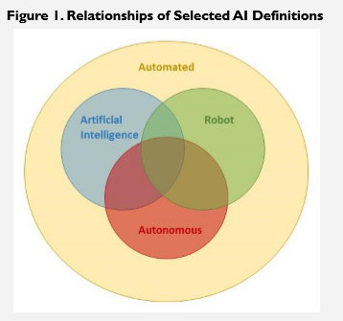

- In 2018, the USA had invested $9.3 billion dollars into Narrow based AI (referring to intelligence that is able to mimic human intellect and learning patterns. With more than 600 corporate entities working on their own AI projects, the USA identified AI as a tool that can be applied in various industries. However, they are more concerned about their national security.
- Although it is mostly used for commercial purposes, the USA is searching for ways to exploit AI for their own national interests. These interests include logistical analysis, using real time data extracted from military vehicles such as the F-35 aircraft, maintenance schedules and the ordering of parts can be tailored.
- Much like automated cars, the USA department of defence is integrating automated vehicles in areas of combat. A current prototype F-13 auto fighter jet serves as a designated “wing man” for other pilots. It analysis aerial and terrain effects and provides extra firepower, minimising human intervention and risk.
- Staff General Paul Selva said, “I do not think it is reasonable for us to put robots in charge of whether or not we take a human life.” Despite having the ability to produce Lethal Autonomous Weapon Systems (LAWS), the US congress still openly discusses the possible pursuit of this technology.
- LAWS states that for the directive action to take another human life, it requires that all systems, regardless of the autonomous system, be have commanders and operators to exercise appropriate levels of human judgment over the use of force”
- If you want to look for more information, feel free to look at https://fas.org/sgp/crs/natsec/R45178.pdf
- 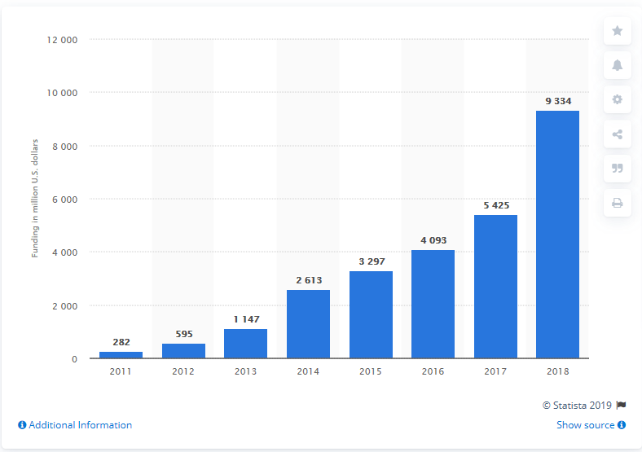
AUS
- The core principles for AI the Australian Government has adopted along with other international bodies include:
  - 1. Generates net benefits. Must generate greater benefits than the costs
  - 2. Do no harm. Must not deceive people or physical harm.
  - 3. Regulatory and legal compliance. Must comply with existing laws
  - 4. Privacy Protection. Ensure that people’s private data is protected.
  - 5. Fairness. Must not discriminate against groups or individuals.
  - 6. Transparency and Explainability. Informed impact of the uses of an automated process.
  - 7. Contestability. A person must be able to influence or change the automated process.
  - 8. Accountability. The creators of the autonomous process is responsible for its impacts.

International responses to AI ethics.

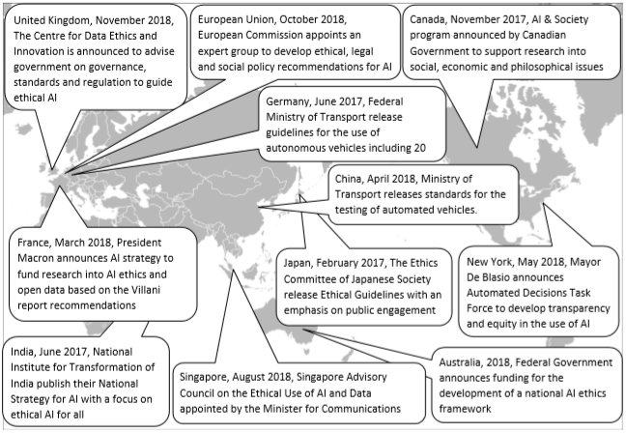

- The Department of Transport Australia has agreed to reconsider the National Transport Commission (NTC) in favour for automated cars. It requires organisations to engage with the public through their trials of automated vehicles. Currently, the NTC allow level 4 autonomous cars (cars that can drive itself but has an option for human control) in cities such as Melbourne and Sydney. However, corporate entities such as insurance companies need to be addressed due to accountability issues.
- “for compliance with road traffic laws when a vehicle has conditional automation engaged at a point in time” ~ NTC line 155.

- Australia predicts there will be a continued growing interested for these vehicles with global sales expected to reach $1 million is 2027. The country wants to pursue this technology for possible economic interests.
- A study by commissioned by the Department of Transportation concluded that safety is the greatest benefit in this new emerging technology. The research found over 90% of car crashes are due to human error - 40% are caused by distractions. Without the human driver, these risks are removed and reduce the number of yearly accidents by 90%.
- However there are still concerns including glitches (such as the death of Elaine Herzberg who was killed by an automated car) and digital vulnerability (hacks).
- For more info please look here: https://consult.industry.gov.au/strategic-policy/artificial-intelligence-ethics-framework/supporting_documents/ArtificialIntelligenceethicsframeworkdiscussionpaper.pdf

Secondary sources

- According to the media and the opinions of the working class, attitudes towards automation and robotics within the manufacturing industry has caused skepticism within the entire employment sector. Examples include: <https://www.reuters.com/article/us-amazon-com-jobs-automation-insight/amazon-scraps-secret-ai-recruiting-tool-that-showed-bias-against-women-idUSKCN1MK08G>

- Global policy makers and institutions have adopted the Ethical Automation Toolkit. Refer to Key Definitions on section 4. for the full explanation of Ethical Automation.
- The Australian ethical automation toolkit is still under public discussion as there is still room for improvement.
- Jobs are not the only issues brought up by the media, outsourcing materials to build these machines often involve unethical methods, environmental damage and forced labour.
- Toyota has released a press release outlining their decision to replace their robots with humans in order to integrate “human centered design elements” and craftsmanship. Although the company will sacrifice production efficiency. There are positive media coverages on this incidence, but does not address the overall fear of automation.
- Historically, machines have been replacing jobs as early as Gutenberg’s printing press or the industrial railway revolution in 1850’s. We may not realise but technology has been replacing us whether we like it or not.
- Currently, there is no immediate threat at AI will take over jobs because artificial intelligence cannot mimic human empathy.

Stakeholders

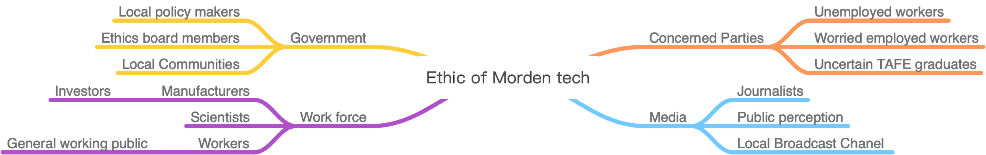

Government

Local policy makers provide legal rights for the creation of advanced technology to ensure that scientists and companies follow certain guidelines to avoid doing harm to the community. To encourage greater support for robotics the government needs to be ensured of their safety and practical application. Greater support from the government will also trickle down to public circles with policies and legislation. Local government is also vital for modern technology. As many local councils have jurisdiction over their inhabitants and investment in technology infrastructure, in many cases they have a say over how effectively modern technology can be implemented. Ethics board members are in charge of evaluating the ethicality of the product creation, their judgments will affect the policy makers decisions. To make sure that the people can accept the new technologies, and the new technologies not break the ethics roles.

Workforce

Scientists and manufacturers have the knowledge and skill sets to invent the automated machines. Ensuring that they are aware of the current fear and criticisms from the public allow them to be more cautious when producing the product to avoid future damage. Investors/partners will play an important role to integrate our campaign. Investors like Uber and Amazon assists our campaign by providing the basic framework for automated machines. Workers, especially those directly interacting with robots are highly affected. As companies automate workers and associated unions may reach out to employers and robotics manufacturers. Workers in general may also feel inclined to use robots in their workforce, making their jobs more efficient or even redundant.

Media

Key mainstream media organisation such as The Guardian, Forbes and The Age have the power to influence public perception of technology and any potential crisis. By staying informed with media representation of automation we are able to better discern public understanding and opinions. Ensuring support from key media outlets is crucial for change, in the direction of robotics. If public support for robotics falls too low it could be completely rejected by the nation. As the public is the most important stakeholder for societal change they must be regularly consulted to ensure they are indeed supportive of robotics.

Communication Problem/Gap/Opportunity F

The clash in the workforce of humans and robotics has led to poor public support for further development of automated machines. This short term thinking is hindering societal development in the long run, keeping industrial advancements suppressed. Currently, there are some attempts at addressing this problem, including the adoption of an automated nurse in Townsville hospital. Overall, the media presentation of robotics has also been negative, focusing on the individual human effect over the broader issue.

Target Audience/s

Primary target audience:
- Young people age 16 to 22
  - Represent future development because they belong to the stage of learning
  - Better at flexibility and adaptation
  - They can better understand the benefits brought by modern technology
  - Encourage them to future technology contributes

Secondary target audience:
- Middle class workers whose jobs have been replaced by automated machines
  - Represent current situation because most of their potential job opportunities are lost
  - By promoting the benefits of modern technology, this part of the population will be less anxious.

Message

The purpose of the project is to change the target audience's attitude towards modern technology so that people understand the convenience that technology brings to society. The simple jobs that make the unemployed or facing the unemployed redundant are seen as opportunities for social development and skills improvement, rather than hating new technologies to work. Young people worry about their future employment prospects in a rapidly changing industry and encourage them to learn new technologies through projects instead of excluding them. Let ordinary people see the convenience that modern technology brings to life, not just worry about it.

Communication Solution

By providing users with an ethical automation toolkit, it will help target audiences. The Ethical Automation Toolkit is a holistic process that addresses public understanding and resolve conscious and unconscious biases in automation. Raise public awareness in the form of an ethics toolkit to eliminate the harmful effects of automation. Use today's popular social media, such as YouTube, to communicate the benefits of automation to the younger public; the website format can provide information to those who already work and sponsor social media influencers. The campaign will tackle the growing fear of unemployment through redundancies caused by technology.
The Ethics Toolkit is only a preliminary version, and it encourages further collaboration with the public.

Point of Difference F

In order to generate rapport between robotics and humans, an exhibition will be organised. The series of events and activities include, but not limited to:
- Robotics convention showcasing the years advancement in industry technologies.
- Competitions focused around working with technologies to complete tasks.
- Industry training workshops, learning technology can increase efficiencies.

Coupled with new technologies these events will put robotics at the forefront of conversation about industry. So far discourse around technology has focused around the supremacy over human counterparts. These activities allow technology to be put on an even footing, enhancing human workers rather than replacing them.

Communication Channels F

[Summarise the chosen media and communication channels your project will use to distribute/disseminate its artefacts/collateral. Provide an overview of any background research you conducted into these channels e.g. the media consumption habits/behaviours/preferences of your target audience; suitability of channel/publication/platform, relevance to or interest in the project, and statistics relating to channel/platform/publication audience demographics, coverage, readership etc.]
[Approx 200-300 words, depending on how many channels you have. Note, you may prefer to represent this in a table format.]

Communication channels | Methods
Facebook and Instagram | Paid Facebook ads will be used to market the artefact to middle age as they are active Facebook users. The ads should present itself 3 times a day on the news feed, not more than that to avoid irritation.  Celebrity endorsement on Instagram will be used to attract younger audience. The paid influencers must be in our niche and have similar content. They will set up IGTV on robotics/tech product review and educating the audience about technology using infotainment strategy.
Forbes | Forbes has high reputation on generating articles and they also have strong audience engagement. Pitching our journalism story to them for publication will boost the awareness of the situation as well as allowing the audience to discuss the matter. Either way, the artefact and will also be promoted in the article.
Radio | Ads on the event launch will be implemented on local radio channels to inform our target audience (Parents who drives, Kids, Middle class workers).
Billboards and Posters | Artefact will be presented on big billboards along main highways and the CBD area. The highway areas will target older audience with Family while they are traveling.  The CBD area will target younger folks as it is the “hangout” spot. SInce billboards in a traditional outdoor advertising medium. It is cheap and can generate viewership.
Snail mail | Invitation mail filled with campaign information and merchandise will be sent to each household in Port Phillip area.

Project Timeline
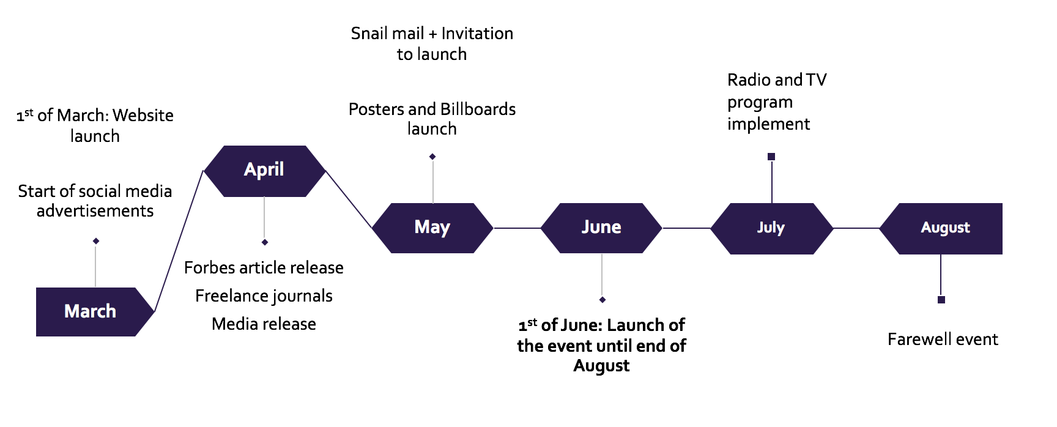

References

Australian Government Department of Industry Innovation and Science, 2019, Artificial Intelligence: Australia’s Ethics Framework, Data61 CSIRO, viewed 5 December 2019, <https://consult.industry.gov.au/strategic-policy/artificial-intelligence-ethics-framework/supporting_documents/ArtificialIntelligenceethicsframeworkdiscussionpaper.pdf>
Congressional Research Service, 2019, Artificial Intelligence and National Security, CRS Report, viewed 6 December 2019, <https://fas.org/sgp/crs/natsec/R45178.pdf>

Dastin, J, 2018. Amazon scraps secret AI recruiting tool that showed bias against women, Reuters, viewed on 04 December 2019, <https://www.reuters.com/article/us-amazon-com-jobs-automation-insight/amazon-scraps-secret-ai-recruiting-tool-that-showed-bias-against-women-idUSKCN1MK08G>
Wakabayashi, D, 2018. Self-Driving Uber Car Kills Pedestrian in Arizona, Where Robots Roam, The New York Times, March 19 2018, viewed 4 December 2019, <https://www.nytimes.com/2018/03/19/technology/uber-driverless-fatality.html>
Wilshaw, P, 2018. The ethical automation toolkit, Towards Data Science, May 22 2018, viewed 4 December 2019, <https://towardsdatascience.com/the-ethical-automation-toolkit-f1fd4281534e>
Manyika J, Chui, M, Miremadi, M, Bughin, J, George, K, Willmott, P, Dewhurst, M, 2017, Harnessing automation for a future that works, McKinsey & Company, January 2017, viewed 4 December, <https://www.mckinsey.com/featured-insights/digital-disruption/harnessing-automation-for-a-future-that-works>
Holst A, 2018, Artificial Intelligence funding United States 2011-2018, September 13 2018, viewed 5 December 2019, <https://www.statista.com/statistics/672712/ai-funding-united-states/>
Nona . K, 2019, Amazon warehouse discussed for site just minutes from the Lake Nona area, Lake Nona Social, May 2 2017, viewed 5 December, <https://lakenonasocial.com/amazon-warehouse-discussed-site-just-minutes-lake-nona-area>
Reynolds, K, 2019, The End of Driving: The Promise and Pitfalls of Autonomous Cars, December 4 2019, Motor Trend. viewed 6 December 2019, <https://www.motortrend.com/news/the-end-of-driving-autonomous-cars-future/>
Nisen, M, 2014, Toyota is becoming more efficient by replacing robots with humans, Quartz, April 2014, viewed 5 December 2019, <https://qz.com/196200/toyota-is-becoming-more-efficient-by-replacing-robots-with-humans/>
Fernbach, N, Rafferty, S, 2019. Townsville Hospital hosts humanoid robot in Australian first trial, ABC News (Australian Broadcasting Corporation), viewed 10 December 2019, <https://www.abc.net.au/news/2018-08-24/townsville-hospital-trials-robot-helper/10157200>

Project Report Appendix
NOTE: All relevant information included here should also be provided on your project showcase website. When formatting appendices, each appendix should be separated by a page break (i.e. start on a new page).

Appendix A: Background Documentation

Project Ideation

[Provide evidence of your project ideation and creative problem solving – i.e. the development of your project ideas/concept. This may include relevant mindmap/s and brainstorming activities and/or evidence of additional research you have conducted (such as end-user testing and feedback on your prototypes) etc.]

Upon the initial research stage, our group first started off with a rough empathy map, outlining the details of human design thinking and the process we want to adopt.

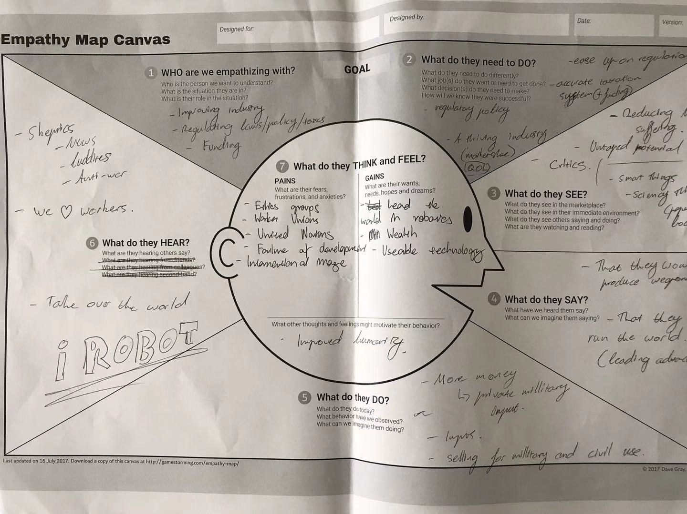

In the following draft our campaign outlined empathising with industry leaders and policy makers, as they have a stronger grasp in the technology industry, influence and most beneficial recipient. Auto-MATE campaign aimed ease up regulations controlling commercial “daily” automation to encourage a more efficiency within the workplace.
Stakeholder Robots/Automation (sourced from our digital brainstorming documents)
- Government
  - Funding for military purpose = link to ethics
  - Boost country’s reputation
  - Relationship: Strong
- Producers (Investor and scientist)
  - Passionate about building the robots
  - Discrete to avoid danger
  - Relationship:
- People being affected by robots
  - Making jobs redundant
  - Relationship: Unstable but could adjust
- Aspire scientists/Students
  - Future generation to better the quality of the robots
  - Relationship: Motivating and inspiring

Our campaign wanted to clear up the stigma around automation within the employment sector to it will benefit our stakeholders - as automation cuts labour costs. However, we ran into our first communication problem as our objectives do not align with the objectives of stakeholders and target audience.

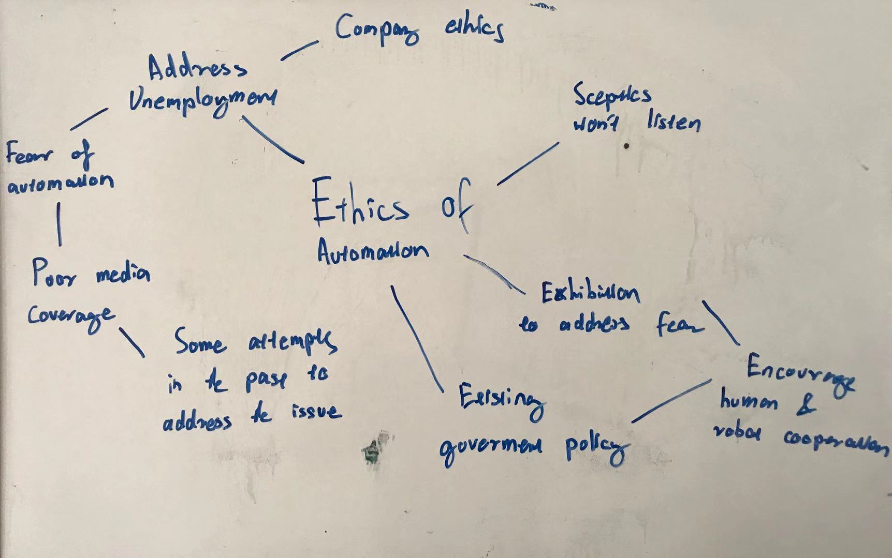

Our second brain storm, we shifted our perspectives and interests away from industry and governmental bodies and began thinking about representing the middle working class, young people (16 to 22) and technology sceptics. Our purpose shifted away a financially driven objective to an awareness objective. We hope to establish a campaign that would address the fear of future unemployment.

Prototype 1: Communication problems and ideate solutions (sourced from our digital brainstorming documents)
Change (target audience) mindset
- Job losers seeing jobs that are becoming redundant. Seeing it as a opportunities for societal growth and to refine one's own skills.

- Young are worried about their future prospects in a changing industry. Aspire them to embrace technology rather than be luddited against it.
Pitch
- Goal: Funding for exhibition and ads
- Key stakeholders
  - Government and Investors
    - Because the government want to increase efficiency and boost the country's GDP
      - Job losers will develop better skills for more advanced jobs = better societal growth
    - Investors
      - Implement technologies in their own companies
      - Their employees won’t pull a strike when their jobs has been replaced

The first concept of our communication strategy was to host a community event in Melbourne’s exhibition centre to interact with new advancements in automation technology.

User experience outline (Draft)

- The exhibition entrance is free of charge.
- The entrance of the exhibition will feature guidelines to all the demonstrations and attractions by different companies and startups.
- The visitor will first engage with large technology booths from major developers like google and car manufacturing business. See the technology perform real time tasks.
- As the user progresses further back, the smaller the booths.
- Timely events will be hosted during the exhibition session. Enabling Visitors to win prizes

After the initial conception of our first idea, we received feedback from peers that our target issue is too generalised and fails to capture the attention of “sceptics”, because only technology enthusiasts would go to a technology related event. Unfortunately, our strategy had to be adjusted, and a new communication solution was constructed.

Based on verbal feedback received during our work in progress pitch(s). The Auto-MATE campaign was re-developed to respond to the fear and negative publicity in automation rather the addressing employment. Integrating advertising, online interactive content and an exhibition. A new campaign plan was formed to engage the wider Port Phillip community, including the sceptics.

Research Documentation

[Provide evidence of your research – i.e. an annotated bibliography of your secondary sources, summarized examples of existing communication solution/projects associated with your topic, research you conducted with your target audience/s, feedback you received from your end-users etc.]

As apart of our research to determine the legitimacy of the fear for technology, a survey was created to outline the severity of the issue. Posted on various messenger boards, the 27 responses confirmed our initial research that technology is portrayed negatively by the media. The form could be found here: https://docs.google.com/forms/d/e/1FAIpQLSfjz31lwYDS2XTtPj_n2goTWytK0PPcxqq_vMuBho-VSOI9sg/viewform?usp=sf_link

Primary Sources
- Australian Government Department of Industry Innovation and Science, 2019, Artificial Intelligence: Australia’s Ethics Framework, Data61 CSIRO, viewed 5 December 2019, <https://consult.industry.gov.au/strategic-policy/artificial-intelligence-ethics-framework/supporting_documents/ArtificialIntelligenceethicsframeworkdiscussionpaper.pdf>
In a report commissioned by the Australian Department of Industry Innovation, outlines the various international policies used to ensure ethical practises with the adoption of automated processes, particularly in transportation. The core principles for AI include but are not limited to, generates net benefits, do no harm, comply with current regulatory and legal standards, ensure privacy and etc.
Useful for our research, the government reports outline current AI legal concerns through case studies and policies that aim to address them. It suggests that the fear of AI could have stemmed from recent accidents which human and machine accountability could not be differentiated.
Most importantly, the report illustrates that current level 4 automated vehicles and machines do comply with Australia’s National Transport Commission policy. With this information, we can establish our campaign and communication message in-line with supported government policy.

- Congressional Research Service, 2019, Artificial Intelligence and National Security, CRS Report, viewed 6 December 2019, <https://fas.org/sgp/crs/natsec/R45178.pdf>
Acknowledging the rapid advancements in artificial intelligence and automation, especially in the commercial sector. Although most automated technology has not been adapted for military purposes, the United States of America, Congress has the ability to influence future military technology development.

In the commissioned report, it discusses the ethical implications of having fully autonomous vehicles. Notably, it outlines issues of privacy, threat to cyber space and “deep fakes” and possible solutions. Currently, the US adopts a similar set of AI principles to Australia, however that may soon change.

The current policy for Lethal Autonomous Weapons (LAWS) is being reconsidered allowing greater autonomy in both the industrial and military use vehicles - nothing has come to fruition.

Implementing into our research, the statistics provided by the report gives us indications of the rapid growth/interest in automated technology. If such growth is to be expected, then it is more apparent that the fear for the development of LAWS must be addressed.

- Dastin, J, 2018. Amazon scraps secret AI recruiting tool that showed bias against women, Reuters, viewed on 04 December 2019, <https://www.reuters.com/article/us-amazon-com-jobs-automation-insight/amazon-scraps-secret-ai-recruiting-tool-that-showed-bias-against-women-idUSKCN1MK08G>
As part of our research, we must understand how the media currently portrays automation. An article published on Reuters outlines Amazon’s recruiting system has “taught itself” to preferably hire men, instead of women.

The main issue was that during the AI’s development, the data it was given to self improve, was screwed (unintentionally) to favour men. As a result of human error, the accountability was on behalf of the programmers who overlooked the data used.

Enforcing our previous research, the principle of AI accountability was overlooked by the media outlet, and the blame was shifted to the automated system and Amazon themselves. Amazon has since corrected their systems but the article author remains doubtful.

- Wakabayashi, D, 2018. Self-Driving Uber Car Kills Pedestrian in Arizona, Where Robots Roam, The New York Times, March 19 2018, viewed 4 December 2019, <https://www.nytimes.com/2018/03/19/technology/uber-driverless-fatality.html>
Exploring the death of Elaine Herzberg, the first person to be killed by an automated car. The article digests the pursuing legal trials. On one hand, the article serves as a reminder for the public to fear technology, but on the other hand, it argues that self driving car policies should tighten.

What the author failed to acknowledge was that the death of Elaine Herzberg was due to human error. Although an intensive investigation of all vehicle components occurred following the incident. The supervising driver in the vehicle was responsible for the accident.

Despite it being a case of human error, the technology is poorly portrayed in the online publication. This article serves as further supporting evident to our targeted problem.

- Wilshaw, P, 2018. The ethical automation toolkit, Towards Data Science, May 22 2018, viewed 4 December 2019, <https://towardsdatascience.com/the-ethical-automation-toolkit-f1fd4281534e>
The ethical automation toolkit is a rough guideline of ethics, agreed by the general scientific community, when adopting AI in the workplace and our everyday lives. As mentioned before, Australia and the United States adopt their own variations of this ethics guideline.

Through there are still more room for development. It outlines that all integrated automation aims to serve humanity's interests, reduce harm and increase efficiency - which aligns with our communication purpose.

- Manyika J, Chui, M, Miremadi, M, Bughin, J, George, K, Willmott, P, Dewhurst, M, 2017, Harnessing automation for a future that works, McKinsey & Company, January 2017, viewed 4 December, <https://www.mckinsey.com/featured-insights/digital-disruption/harnessing-automation-for-a-future-that-works>

Taking a more optimistic angle. The article provides an example of the positives of automation. From a brief historical perspective, it outlines industry development, growth in productivity throughout the early 2000’s.

Encouraging mutual cooperation between people and machines, particularly in areas requiring empathy. It outlines areas that require human intervention and manual assistance. Though many workers will lose their jobs in the process, it is more about a “shift” rather than a complete loss.

Despite not being a campaign to address the larger issue, it serves as a “starting” point that will assist the development of our campaign.

Holst A, 2018, Artificial Intelligence funding United States 2011-2018, September 13 2018, viewed 5 December 2019, <https://www.statista.com/statistics/672712/ai-funding-united-states/>
A graph sourced from Statista outlining the growth in AI funding in America. Aligning with the AI report by the US Congress, it suggests an increase trend in cooperation research and development in the field of automation.

It supports the idea that automation will continue to grow, and societal attitudes need to be addressed before further development.

- Nona . K, 2019, Amazon warehouse discussed for site just minutes from the Lake Nona area, Lake Nona Social, May 2 2017, viewed 5 December, <https://lakenonasocial.com/amazon-warehouse-discussed-site-just-minutes-lake-nona-area>
As a part of our facebook/artefact mockup, the campaign sourced images from the following article

- Nisen, M, 2014, Toyota is becoming more efficient by replacing robots with humans, Quartz, April 2014, viewed 5 December 2019, <https://qz.com/196200/toyota-is-becoming-more-efficient-by-replacing-robots-with-humans/>
Addressing the fear of redundancy in the car manufacturing, Toyota released a multiple press releases as a part of a public relations campaign, justify their minor loss in production efficiency.

Focusing on human centred design, the company believes by sacrificing efficiency for craftsmanship, it improves the car in ways no machine could.

Analysing Toyota’s PR campaign press release, the company promotes “human orientated skills” that require emotional thinking and niche expertise. For our campaign, we hope to encourage the same level of mutual cooperation between technology and society. By encouraging people to assist machines when performing emotional related tasks, it addresses the fear associated with technology.

- Fernbach, N, Rafferty, S, 2018. Townsville Hospital hosts humanoid robot in Australian first trial, 28 August 2018, ABC News (Australian Broadcasting Corporation), viewed 10 December 2019, <https://www.abc.net.au/news/2018-08-24/townsville-hospital-trials-robot-helper/10157200>
In Townsville Australia, the first hospital social robot named “Pepper” was introduced as a simple “patient interaction” partner. Stemming from the lack of healthcare professional to answer simple patient questions. Pepper was introduced, programmed with information about the hospital and basic health knowledge.

The intention of robot was apart of the hospital’s plan to integrate online and digital visitor and patient assistance. However, it is currently seen as a “fun novelty” item to have rather than a healthcare assistant.

For our campaign and exhibition, we hope to use robots as both a “novelty” and tool that can assist the Port Phillip community. By demonstrating some practical uses, like Townsville hospital with “Pepper”, the exhibition will gain public attention.

Team Work Documentation

[Include copies of your team contract, overview of team roles, meeting minutes, production planning, peer feedback, etc. AND copies of your individual 500-word reflective responses from each team member]

Reflective Responses
[Each team member must critically reflect on their team work experience over the duration of the course. This response must be posted to your individual blog, but a copy (and link to your blog post) must also be provided here as part of your documentation.]
[Approx 500 words for each response]

Boris

Starting in November we are all placed into groups for the main project of the subject. Placed in a group with Fern, Will and Romy we soon began to work on the topic ‘ethics of technology’.

Fern’s reflection
https://sengfernsathatham0.wixsite.com/mysite/post/final-assignment-reflection

Romy’ reflection
https://romyxu.home.blog/2019/12/18/reflective-about-group-work/

Presentation Materials

[Include copies of your WIP presentation materials and pitch deck]

Appendix B: Creative Communication Campaign/Strategy/Plan

Issue
As robotics and automated technologies enter the market at increasing rates, people are becoming more fearful of safety issues caused and greater irrelevance of human input. The growing worry of such technologies is leading to groups intentionally holding back robotic advancements. This short-term thinking is compounded by media attention and lack of understanding from lack of engagement of such technologies.

Goal
The overall narrative the campaign aims to convey is the safety and reliability of robotic technologies. As public awareness of technologies is high but not sophisticated we will aim to disseminate many of the myths surrounding automation. Increasing public trust and local council support the campaign will encourage and future for robotics in Australia.

Target Audience/s
Our first primary target audience of this campaign will be kids age from 10 to 16 since we want them to get familiar with the future robot launch at their schools. It is the parents' job to bring their kids to the campaign launch event which also make them our primary target audience as well.

Secondary target audience will be the middle class industrial/factory workers, we aim to motivate them to join our event launch to hopefully inspire them to develop better skills for better jobs.

Communication Methods
The communication strategy focuses around the core activity of direct engagement with local communities. This will be implemented by subsidising robotic technologies in local government and community spaces such as schools and libraries. The council targeted will be the City of Port Phillip Council. Close to Melbourne centre and with a high, but moderately dense population.

Taking advantage of the new National Transport Commission, Auto-MATE plans to introduce three level four autonomous vehicles onto the streets of Port Phillip as a means of free public transport. Partnered up with Uber, a rideshare company, users are able to select “Autonomous” car option when navigating in the operational area. The demonstration of roaming automated vehicles both in the Albert Park racing track and the streets of Port Phillip will bring the community closer with automated technologies.

To ensure greater media attention the initial campaign will be run over the Australian Autumn and winter months (March till August), during this period there are few public events and holidays to detract attention away from the campaign. The winter months also ensure a cool and stable temperature, perfect for robotics, as well as focusing the robotics on more reliable indoor processes.

Our advertisements and official website will launch on the first of March before the physical launch of Auto-MATE’s robots in June. This gives us three months prior to make sure the targeted publics are aware of the event. The social media advertisements will run from beginning till the end of the campaign and the website will always be accessible online.

After the publics are being exposed to our advertisements for one full month, the start of April we plan to incorporate more credible sources such as news article provided by Forbes, local freelance journalists, and a media release. This publicity will boost the campaign’s reputation given that the selected media channels represents Auto-MATE in well mannered professional way. The articles will always be accessible online from the day that it is published, encouraging ease of access.

A month before the event launch (May), we plan to send out snail mail invitation to each household of The Port Phillips Community. The physical mail will include a brochure of the event as well as memorable merchandise such as keychains and magnets of a robot figure with an engraved launching date on it. These small details will grasp their emotional attention and it will contribute to higher turnout for the launch and overall support.
After the initial three month advertising campaign, on the fifth of June (Friday) is where our introduction launch happen. We want our demonstration to run throughout the whole weekend as majority are free from school and work. We aim to exhibit our robots at Albert Park as it is located in the middle of Port Phillips, allowing people from both ends to travel easily.

The start of the event launch week, we plan to implement guest slot on related program show such as breakfast TV to go over our event as well as reminding the audience of the whole campaign. Local radio broadcast will also be executed during and after the campaign launch with the same goals to achieve as the TV program.

Our campaign pilot program will be executed from 8th of June (as that is a day after the introductory launch) until the 28th of August where winter is coming to an end. The reason why the campaign ends on the 28th is because we want to use that weekend to have a farewell event, re-inviting people who have visited our campaign launch to come back and tell us their experience.

The targeted community will incorporate a partnership with Albert Park Primary School and St Kilda library. Customer service and logistical robots will be “leased” for free during the week leading up to the event. The partnership will include a live robot tracker on the Auto-MATE website as a part of an online interactive initiative.

NOTE: Assessment requirements indicate that as part of your Project Report, you must also include a Project Timeline and Background Research into your chosen media channels/platforms/publications and the media consumption habits/preferences/behaviours of your audience. The communication methods identified here should be incorporated as elements in your project timeline, and your decision making throughout your campaign/strategy should be informed by your background research.

Objectives

To achieve at least 30% of social media and official website engagement by the 31st of March 2020
To achieve at least 45% of public awareness through credible publication channels (Forbes and freelance journalist) and media release by 1st of May 2020
To achieve at least 35% of responses from snail mail invitation to at the launch event by 25th of May 2020
To achieve at least 45% turnout rate for introductory launch by 7th of June 2020
To achieve at least 50% of positive mindset of our target audience by 31st of August 2020

Appendix C: Project Artefacts

Communication Campaign/Strategy Artefacts

[Produce all campaign/strategy artefacts/collateral associated with your communication campaign/strategy to a prototype stage e.g. social media posts, advertisements, media releases, event outlines, etc.]

Media Artefact/Story

[Produce a media artefact/story to prototype stage e.g. video, podcast, interactive website, or other artefact suitable for your project and target audience. This should be an integrated part of your creative communication campaign/strategy/plan]
Hello residents:

Good day! How are you?

We hereby sincerely invite you to participate in a technology exhibition we held on 5 June 2020 in Albert Park. This is an exhibition about robots, and our robots will be displayed at the event. Enclosed is a booklet about the content of our event and a keychain about our robot image.

It would be a great pleasure to meet you at the exhibition.

Exhibition Place: Albert Park as it is located in the middle of Port Phillips
Date: 5 June 2020

Thank you very much for your attention.

sincerely yours,
Auto-MATE

Media release

Robot’s in Port Phillip

Auto-MATE
William, Fern, Boris, Romy
0425000000

Auto-Mate is rolling out robots right.

Starting from the first of March of 2020, Auto-Mate will be putting robots in the City of Port Phillip. All over the City of Port Phillip advanced automated technologies will be working with humans to enhance life.

Realising the public fear and poor media display of robotic technologies, fear of lost jobs and public danger, were high on Australian minds. The demonstration launch by Auto-MATE begins on June the 5th of 2020. Automated technologies will be integrated around the community - as a part of a 3 day weekend long demonstration. Public spaces such as St Kilda Primary School and St Kilda library will be home to our new mechanical friends.

During school times and opening hows robots will be in the world, for interaction at your pleasure. The public can see robots in action and interact with those available. The goal of the campaign is to encourage the use of robotics for real world applications.

“Hollywood and the media always portray robots as an impending danger that are ready to make humanity irrelevant,” said Boris Pribil, Auto-MATE’s campaign manager, “this short-term thinking is hindering Australia’s technological development.”

As robots continue to bring benefits to humanity, Auto-MATE hopes Melbourne will embrace automated technology bettering human life and our environment.

Auto-mate

Journalism Story Pitches

Local
[Identify the local target publication/s and/or journalists/editors that you would pitch the story to. Write a persuasive pitch for a story suitable for the target publication.]
[Approx 80-100 words]

To Herald Sun,

The City of Port Phillip is getting a new facelift. Starting in mid to late August 2020, robots will be roaming the streets, libraries and schools as apart our “Auto-MATE” campaign. We hope to introduce and familiarise local residents about the convenience and quality of life improvements automation could bring.

One of the first few recipients of our campaign is Albert Park Primary School, with automated logistical and social robots that assist teachers and students.

Similar to your article; “SUCCESS FOR FIRST SCIENCE AND TECH FESTIVAL”, we consider our article as a create addition and follow up story. We hope the public can learn more about automating content.

Sincerely,
Auto-MATE

We have an article of automation, and the main idea is tantamount to spread the word of automation to the masses. We want to publish the article in your publication. We learned that the herald sun is a newspaper for local news in Melbourne. Posting articles in your company can let Melbourne residents know about technology around them and let them think about automated information.

National
[Identify the national target publication/s and/or journalists/editors that you would pitch the story to. Write a persuasive pitch for a story suitable for the target publication.]
[Approx 80-100 words]

“Machines are taking over!” cried every media outlet. We all have heard the mass redundancies in the automotive industry, and threats imposed on our employment, but are often glorified by the media. What we hope to share with Inside Robotics Australia is the cooperation between artificial intelligence within the same workplace. Exploring the benefits of automation, worker’s health and wellbeing has improved dramatically as a result of technological advancements.

Similar to other Industrial Robots Organisations articles Inside Robotics have published, exploring industrial applications, this story would make a great addition.

International
[Identify the international target publication/s and/or journalists/editors that you would pitch the story to. Write a persuasive pitch for a story suitable for the target publication.]
[Approx 80-100 words]

Hello Scientific American .
We have an article of automation , and the main idea is to spread the word of automation to the masses . We want to publish the article in you . We learned that Scientific American is an undergraduate magazine . It was founded in 1845 . You are the longest-standing American magazine . Unlike other scientific magazines , Scientific American is not a purely academic magazine , and its popular science alternative can be read by the public . We think our article fits your positioning very well . Inform the public about technology in simple language.

To New York Times,
Silicon valley is preparing for a new era of technology, and it is coming to Melbourne first. Since 1997, automated technology has been on the rise, and sooner or later they will be apart of our everyday lives. Here at Auto-MATE, an Australian based artificial intelligence campaign, we aim to bridge the gap between society and robotics.

With all the negative press about automation published on your newspapers and websites, such as Tesla's poor autopilot. Our campaign would like to shed some positive light on this growing industry. We hope, with your influential publishing, we can convince many sceptics the benefits of automation.

and the main idea is to spread the word about automation to the masses. We want to publish the article through you. We have learned that the New York Times is a large newspaper with world influence and a representative of the serious newspapers in the United States. Publishing an article in your company can convince the public of the accuracy of the report and think about the content of the article. We hope the public can learn more about automated content.

Sample News Article
On a warm night in Arizona, United States, a woman named Elaine Herzberg was busy pushing her bicycle through the dark. She had bought some groceries earlier and was making her way home.
After crossing two roads, Elaine prepares to cross the third, but as she set foot on the dark pavement a bright white light flashed before her eyes.
Then, tragedy struck her, literally. On March 18th, 9:58pm, 2018, an automated self-driving prototype car by Uber had struck Elaine at around 70kmp.
Following trial, multiple companies and individuals were investigated to determine human accountability. Stories like Elaine’s served as a reminder of the possible dangers of automation and artificial intelligence.
But here is the catch - incidence reports like Elaine Herzberg’s death is sensationalised.
Let us imagine that instead of a machine, the death of Elaine was the result of a freak accident involving a drunk driver. Sure, for a while the court house would be busy and a couple of journalists would write about it. At the end of the day, the death of another human is nothing new, we hear and see it all the time on newspapers, television and science fiction thrillers like the Terminator.
The reasons why machines are portrayed negatively within media the fear of the inability to control technology. Manufacturing workers lost their jobs not to their own fault, stock brokers lost their jobs not at their own fault, and the death of a pedestrian was not at their own fault.
Someone or rather something has to be blamed, right? So, let us sharpen our pitchforks, light our torches and point it at the machines and the corporations who adopt them.
These concerns about automation and artificial intelligence undermines humanity's technological advancements. Since 1997, humanity has adopted robots as an industry asset. Eliminating repetitive tasks, especially in car manufacturing. As of 2018, Toyota outputs 10% more in crankshaft production.
Automation has reduced repetition so people can focus on more emotional related tasks, reduce workplace risk and increase efficiency.
Doesn’t that sound great?
Imagine having an automated machine clean up the house, drive you to work or even start a conversation with you. Sounds like a dream, right? Well, this is a reality, you do not need to imagine, because it is already here.
Launching in early August partnering with the City of Port Phillip, Auto-MATE campaign will feature a series of automated robots in the local area, performing various tasks in St Kilda library, transporting members of the public and assisting Albert Park Primary School with various logistics.
Incorporated on Auto-MATE’s website, a tracking device is installed on the automated machines to track real time tasks. To ensure the campaign does not resemble a “robot takeover”, the machines cannot operate without human assistance. Auto-MATE hopes to promote the incorporate automation as an “enhancer” in everyday life, rather than a substitute.
“There is a lot of stigma and fear around everyday automation,” said Boris, a campaign member for Auto-MATE, “we hope to see a mutual cooperation between society and technology.”
In essence, automation and artificial intelligence aim to improve human wellbeing. However, rare incidence such as workplace redundancies and accidents have shifted public opinion to grow fearful of what humanity has created. Humanity is going through a technological revolution; we must be able to acknowledge and accept technologies’ shortcomings rather than turning away.

