COMM2676
Contemporary Approaches to Media & Communication

Ethics of Modern Technology and Automation

Auto-MATE Campaign Launch

Project Report


Tutorial: Tuesday, Wednesday and Thursday – 10:30am to 5:30pm
Tutor: Ella Chorazy
Team:
Fern Seng, s3812364
William Xie, s3784791
Boris Pribil, s3782513
Romy Xu, s3637540

Table of Contents

Executive Summary 3

Team Introduction & Roles 4

Purpose 5

Key Terminology 5

Context & Situational Analysis 6

Research Insights 8

Stakeholders 11

Communication Problem/Gap/Opportunity 13

Target Audience/s 13

Message 14

Communication Solution 14

Point of Difference 15

Communication Channels 16

Project Timeline 17

References 18

Communication Stratgy 21
Executive Summary

How are attitudes to industry automation changing and affecting global changes? The following report looks into how the fear of robots replacing human jobs is leading to societal distrust of automation and avoidance of its use. Throughout history humans have constantly been looking for ways to increase production efficiencies, replacing jobs.

The replacement of jobs with automation is led to fear, of both their livelihood and careers. Translating this fear into the 21st Century, many media outlets, as well as labour groups, have seen automated production methods as a threat. Many people reject the idea of everyday automated, including automated transport. This form of short-term thinking is leading to many people to avoid using robots, and societal acceptance of less efficient methods. If the distrust continues technological advance may be stuck, refusing to advance and make human life better in the long run. As many media organisations thrive off fear mongering we aim to provide rational debate regarding automation and to an extent artificial intelligence (AI).

Communication strategies will be implemented highlighting the overall benefits to more efficient production as well as mitigating any threats about the ethics of robotics, especially respecting job losses. To create lasting benefits to our societies advancing technologies must be embraced through the discussion of key stakeholders' interests and demonstration of its benefits.

Team Introduction & Role

Will: Will is primarily tasked with key research and website development. Coordinating with the team he will both assist in overall project concept development as well as timeline coordination. Will has a key task in visual development and transfer to the website and other digital forms.

Fern: Fern is responsible for key strategizing for the communications plan. She is also responsible for all communications outputs and how they correspond with key project objectives. Fern also ensures all stakeholders are sufficiently reached and their issues satisfied.

Boris: Boris oversights of all written materials. Coordinating with the research team he must sufficiently reflect group outputs in verbal means. Boris then coordinates with the visual team to ensure all project artifacts correspond. Boris also partakes in key project concept development and planning.

Romy: Romy is responsible for major project insights. Romy must coordinate these insights with the team to provide visual and written equivalents. Romy is also responsible for infographics, ensuring that they indeed represent key research findings.

Purpose
The project is aimed at changing public and stakeholder perceptions of the use of automation in their daily lives. Changing mindsets will allow for more efficient automation policies that would benefit technological development. This will encourage long term thinking and overall societal benefit.

To change mindset
- Technology should be viewed as as an opportunity for societal growth and to refine one's own skills.

- Young people are worried about their future prospects in a changing industry. Aspire them to embrace technology rather than be against it.

Key Terminology
Ethical automation tool kit. A holistic process used to address public understanding and address the conscious and unconscious biases of automation. In involves the following:
- Human rights - The use of machine must benefit humanity and society
- Improve wellbeing - Autonomous machines must not harm human health and wellbeing
- Accountability - A human must be responsible for operation or error.
- Transparency - Clear intended use of artificial intelligence
- React to misuse

Humans in the loop. Ensures that machines objectives align with various stakeholders - also ensuring accountability.

Context & Situational Analysis
Since the invention of farming, we as humans have continued to develop more efficient ways of producing. In parallel to these greater production possibilities is lost jobs of humans, replaced by automation and recently AI. With more efficient systems inventors have more time to invent and specializations are created, compounding the effect.

Most recently it is intelligent robotics (AI) that are taking the forefront if discourse and social awareness. Many industry leaders and scientists are concerned that more complex human jobs are being completely replaced, no longer just enhancing human abilities. Questions about automation was brought up over a new Amazon recruitment system. The computer program was able to sieve through applicants resume and video’s, looking at keywords, educational pathways and employee performance. Following the initial data the software automatically produced a scorecard, rating the worker and making previously human recruitment officers obsolete. Though creating a more efficient recruitment process for Amazon the system has been brought into question of its overall ethics. The software not only replaces human jobs but supposedly held inherent human biases from the programmers, and exaggerated by the software. As a result the recruitment software the often placing candidates lower according to their gender and other demographic factors. In response many feminist and other rights groups challenged Amazon. The programming of the bot resulted in the technology developing a bias rather than the “deliberately” discriminating against groups. The story was picked up by the media, generating poor coverage at Amazon's recruitment standards and the reliability of automation and AI.

Currently and with further advancements in technology the majority of media portrait automation as a threat to humans. Sceptics state that intelligent automation (AI) may take up to half of all human jobs by 2055, with a 20-year margin of error source. Many of these jobs tend to be lower-income and male, most prominently truck drivers who may become totally obsolete with automated transport. Despite replacing jobs automated vehicles and machines with human contact come under another wave of scrutiny. In 2018 an incident in Arizona USA resulted in the killing of a pedestrian by an automated car owned by Uber. Currently, the law states that “humans must be blamed”, but still led to a large backlash from the public about the ethics of robotics in contact with humans. The accident also led to many stakeholders, including shareholders leaving many technology companies with fears brought up by robotic independence.

The situation of robotics is no longer black and white. With the growing ability for automated machines and AI to self-control has led to questions regarding their place in the world. Many supporters or technology have claimed the benefits of technology. Through a death did occur, self-driving cars have a much lower chance of fatal accidents compared to their human counterparts. Supportive media also elaborates that robots without human interference will be far safer and more efficient. For example, with humans on the road self-driving cars will always have to drive slower to take into account the possibility of human error. In contrast many media organisation portrait robotics as a bad thing. Most recently in Australia, the closure of the Ford factory has led to upset as many jobs were replaced by an automated assembly line. The media's portrayal is generally short-term, the immediate job loss rather than the overall societal benefit of cheaper goods. Similarly, automated checkouts have led to far greater efficiencies in out high-trust societies, but have led to many low skilled and low paid job losses.

Changing industries as a result of robotics and AI have led many people to be sceptical and even fearful of technological advancements. The media's short term, views focused scare campaign of short term thinking has allowed even greater support for luddites. Though the industry is still developing mostly unopposed many are fearful that significant job losses in a short span of time, such as truck drivers, may lead to significant social unrest. The campaign proposed is aimed at tackling this problem, encouraging social and in effect government and industrial support for technologies. Through jobs may be lost in the short term, society will greatly benefit overall.

Research Insights
Today, fear of robotics and advancing technologies is increasing rapidly. The US government (2019) defines artificial intelligence or an autonomous operating process as “any predictable or varying task that can be performed without human intervention”. These systems must, to some degree incorporate ‘artificial intelligence, robotics or autonomy to be classified as an automated system. Such systems are causing increasing civil unrest. As automation improves it is also creating concerns among ethical bodies that automation can be relied upon to perform military tasks.

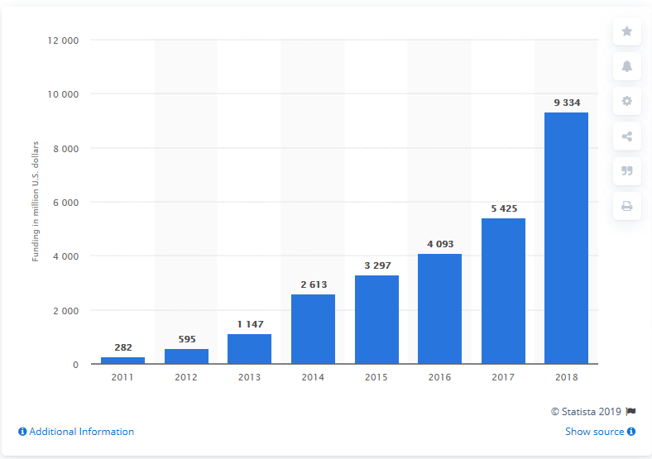
The funding of automation by militaries around the world has grown considerably. In 2014 the USA invested US$9.3 billion into ‘narrow based AI’, defined as intelligence able to mimic human intellect and learning patterns.
Holst A, 2018, Artificial Intelligence funding United States 2011-2018, September 13 2018, viewed 5 December 2019, <https://www.statista.com/statistics/672712/ai-funding-united-states/>

Along with 600 private corporate entities, the main focus of such automated advancements is to primarily further national security interests. The bulk of such robotics current consists of logistical analysis, using real-time data extracted from military vehicles such as the F-35 aircraft. As advancements mount deadly maneuvers are being tested, successfully replacing any human element. The development of military hardware and software has scared the public, serving as a reminder of a possible dystopian future most commonly portrayed in science fiction thrillers like the Terminator.

Currently, the law (2019) states that “humans operators are held accountable” for the repercussions of artificial intelligence. Through many sceptics worry that this could one day change, whereby the potential of AI could destroy autonomously and cause violence, especially if machines are acting so independently that it becomes hard to control. The current prototype F-13 auto fighter jet serves as a designated “wingman” for other pilots. Analysing aerial and terrain effects and providing extra firepower. It has the autonomy to engage, minimising human pilot risks. This specific piece of technology still requires a human to ‘watch over’ the system, but once activated it has full independence.

Despite the ability to produce lethal autonomous weapons systems (LAWS) the US Congress still debates whether to pursue the technology. Staff General Paul Selva says, “I do not think it is reasonable for us to put robots in charge of whether or not we take a human life”. As such all current automated weapons systems still required a direct commanding officer to decide on the appropriate amount of force required.

The debate over autonomous combat is splitting the ethical debate. On one hand, saving lives is a potential but if totally freed, automation can cause unnecessary destruction without supervision. Elon Musk put it, “It’s just like if we’re building a road and an anthill happens to be in the way, we don’t hate ants, we’re just building a road, and so goodbye anthill”. So still robotics are under fire for their still straight forward nature of achieving set objectives and whether automation should continue being allowed.

Along with military use, there has been growing social unrest as a result of automation used in civil applications. Many automated machines are able to completely replace low skilled workers putting many people out of work and encouraging resentment for such technologies.

The most concerning technology for many are automated vehicles. In 2018, Australia had a total of 1145 road accidents in Australia. However, according to a study commissioned by the United States Government, 90% of all fatal accidents are caused by human error, usually by distractions. If the human aspect could be eliminated, many lives could be saved. Acknowledging this The Department of Transportation Australia, Vic Roads with the National Transport Commission (NTC) has agreed to conduct research and generate legislations enabling automated vehicles and their use.

Currently, the NTC allows up to level 4 automation to be tested in Melbourne and Sydney; cars that can drive themselves but requires human operation, and for accountability. However, there are still public concerns about the reliability of technology. Recent cases include Tesla's “smart summon” (Tesla’s automated driving software) hitting and scratching other road users.

Despite these concerns, The Department of Transportation predicts there will be continued growth for automated vehicle applications, with consumer sales expected to reach $1 mil seems small by 2027. Through the figure is rather low, growth will exponentially occur once the technology has matured.

A survey we conducted amongst 27 anonymous respondents. The results suggest around 60% of are concerned with technology overwhelming everyday life, and a total of 63% of respondents believe that technology is being “accurately represented” in the media.

Currently, the biggest benefactors are industry leaders with workers feeling neglected for the sake of cheaper production. Such thinking is short term, and one-sided, overlooking other societal factors and hinders overall societal advancement. Key stakeholders including the media need to be consulted and kept aware of the long term benefits of automated industries.

Automation at such a scale is a new phenomenon and must be thoroughly discussed to ensure a safe transition and the most benefit to mankind.

Stakeholders

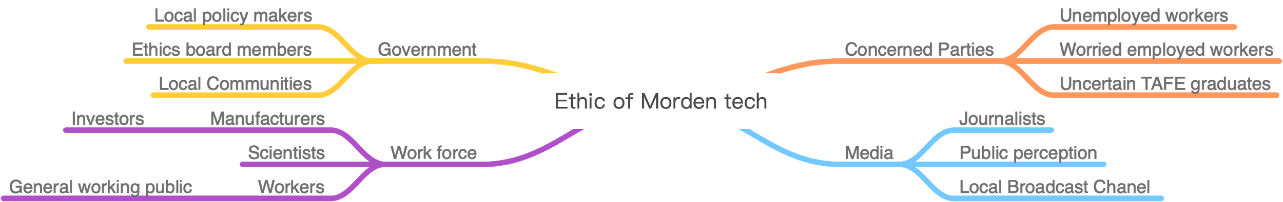

Government

Local policymakers provide legal rights for the creation of advanced technology to ensure that scientists and companies follow certain guidelines to avoid doing harm to the community. To encourage greater support for robotics the government needs to be ensured of their safety and practical application. Greater support from the government will also trickle down to public circles with policies and legislation.

Ethics board members are in charge of evaluating the ethicality of the product creation, their judgments will affect the policymakers' decisions. To make sure that people can accept the new technologies, and the new technologies do not break the ethics roles.

Local communities safety a key government’s priority, as such they will be less inclined to support automated technologies unless they see practical and most importantly safe application.

Workforce

Scientists and manufacturers have the knowledge and skillsets to invent automated machines. Ensuring that they are aware of the current fear and criticisms from the public allow them to be more cautious when producing the product to avoid future damage. Investors/partners will play an important role to integrate our campaign. Investors like Uber and Amazon assist our campaign by providing the basic framework for automated machines.

Media

Key mainstream media organisation such as The Guardian, Forbes and The Age have the power to influence public perception of technology and any potential crisis. By staying informed with media representation of automation we are able to better discern public understanding and opinions. Ensuring support from key media outlets is crucial for change, in the direction of robotics.

Communication Problem/Gap/Opportunity
The clash in the workforce of humans and robotics has led to poor public support for further development of automated machines. This short term thinking is hindering societal development in the long run, keeping industrial advancements suppressed. Currently, there are some attempts at addressing this problem, including the adoption of an automated nurse in Townsville hospital. Overall, the media presentation of robotics has also been negative, focusing on the individual human effect over the broader issue.

Target Audience/s
Primary target audience:
- Young people age 16 to 22
  - Represent future development because they belong to the stage of learning
  - Better at flexibility and adaptation
  - They can better understand the benefits brought by modern technology
  - Encourage them to future technology contributes

Secondary target audience:
- Middle-class workers whose jobs have been replaced by automated machines
  - Represent the current situation because most of their potential job opportunities are lost
  - By promoting the benefits of modern technology, this part of the population will be less anxious.

Message
The purpose of the project is to change the target audience's attitude towards modern technology so that people understand the convenience that technology brings to society. The simple jobs that make the unemployed or facing the unemployed redundant are seen as opportunities for social development and skills improvement, rather than hating new technologies to work. Young people worry about their future employment prospects in a rapidly changing industry and encourage them to learn new technologies through projects instead of excluding them. Let ordinary people see the convenience that modern technology brings to life, not just worry about it.

Communication Solution
By providing users with an ethical automation toolkit, it will help target audiences. The Ethical Automation Toolkit is a holistic process that addresses public understanding and resolves conscious and unconscious biases in automation. Raise public awareness in the form of an ethics toolkit to eliminate the harmful effects of automation. Use today's popular social media, such as YouTube, to communicate the benefits of automation to the younger public; the website format can provide information to those who already work and sponsor social media influencers. The campaign will tackle the growing fear of unemployment through redundancies caused by technology.
The Ethics Toolkit is only a preliminary version, and it encourages further collaboration with the public.

Point of Difference
In order to generate rapport between robotics and humans, an exhibition will be organised. The series of events and activities include, but not limited to:
- Robotics convention showcasing the advancements in industry technologies over certain periods.
- Competitions focused around working with technologies to complete tasks.
- Industry training workshops, learning technology can increase efficiencies.

Coupled with new technologies these events will put robotics at the forefront of the conversation about the industry. So far discourse around technology has focused around the supremacy over human counterparts. These activities allow technology to be put on an even footing, enhancing human workers rather than replacing them.

Communication Channels
Communication channels | Methods
Facebook and Instagram | Paid Facebook ads will be used to market the artefact to middle age as they are active Facebook users. The ads should present itself 3 times a day on the news feed, not more than that to avoid irritation.  Celebrity endorsement on Instagram will be used to attract a younger audience. The paid influencers must be in our niche and have similar content. They will set up IGTV on robotics/tech product review and educating the audience about technology using infotainment strategy.
Forbes | Forbes has a high reputation for generating articles and they also have strong audience engagement. Pitching our journalism story to them for publication will boost the awareness of the situation as well as allowing the audience to discuss the matter. Either way, the artefact and will also be promoted in the article. Either way, the campaign launch will also be promoted in the article.
Radio | Ads on the event launch will be implemented on local radio channels to inform our target audience (Parents who drive, Kids, middle-class workers).
Billboards and Posters | The artefact will be presented on big billboards along main highways and the CBD area. The highway areas will target an older audience with Family while they are travelling. The CBD area will target younger folks as it is the “hangout” spot. Since billboards in a traditional outdoor advertising medium. The billboard will also advertised in The City of Port Phillip as it is Auto-MATE’s launch location. It is both cheap and effective tool to generate viewership.
Media Release | A media release will be distributed to various publications and news agencies (including Forbes) as a paid publication promotion across Melbourne. The extra awareness raised increases the possibility of a larger audience gathering.
Snail mail | Invitation mail filled with campaign information and merchandise will be sent to each household in the Port Phillip area.

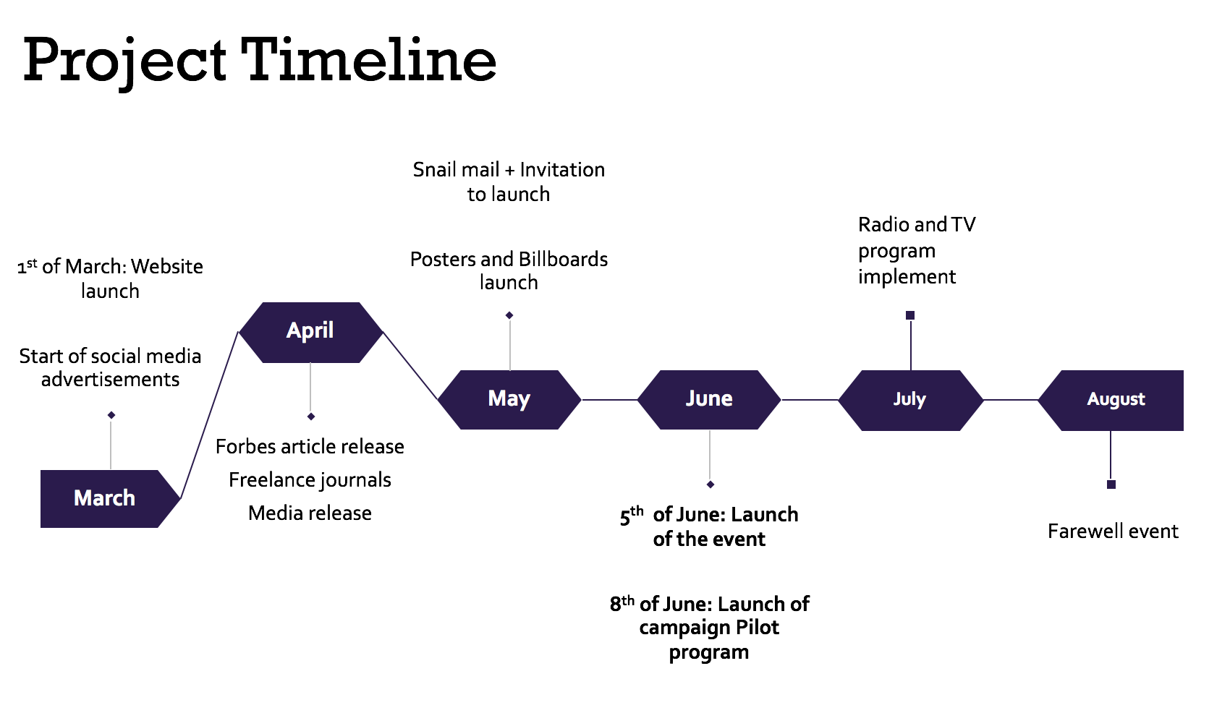

References

Australian Government Department of Industry Innovation and Science, 2019, Artificial Intelligence: Australia’s Ethics Framework, Data61 CSIRO, viewed 5 December 2019, <https://consult.industry.gov.au/strategic-policy/artificial-intelligence-ethics-framework/supporting_documents/ArtificialIntelligenceethicsframeworkdiscussionpaper.pdf>

Congressional Research Service, 2019, Artificial Intelligence and National Security, CRS Report, viewed 6 December 2019, <https://fas.org/sgp/crs/natsec/R45178.pdf>

Dastin, J, 2018. Amazon scraps secret AI recruiting tool that showed bias against women, Reuters, viewed on 04 December 2019, https://www.reuters.com/article/us-amazon-com-jobs-automation-insight/amazon-scraps-secret-ai-recruiting-tool-that-showed-bias-against-women-idUSKCN1MK08G

Wakabayashi, D, 2018. Self-Driving Uber Car Kills Pedestrian in Arizona, Where Robots Roam, The New York Times, March 19 2018, viewed 4 December 2019, https://www.nytimes.com/2018/03/19/technology/uber-driverless-fatality.html

Wilshaw, P, 2018. The ethical automation toolkit, Towards Data Science, May 22 2018, viewed 4 December 2019, <https://towardsdatascience.com/the-ethical-automation-toolkit-f1fd4281534e>
Manyika J, Chui, M, Miremadi, M, Bughin, J, George, K, Willmott, P, Dewhurst, M, 2017, Harnessing automation for a future that works, McKinsey & Company, January 2017, viewed 4 December, https://www.mckinsey.com/featured-insights/digital-disruption/harnessing-automation-for-a-future-that-works

Holst A, 2018, Artificial Intelligence funding United States 2011-2018, September 13 2018, viewed 5 December 2019, https://www.statista.com/statistics/672712/ai-funding-united-states/

Nona . K, 2019, Amazon warehouse discussed for site just minutes from the Lake Nona area, Lake Nona Social, May 2 2017, viewed 5 December, https://lakenonasocial.com/amazon-warehouse-discussed-site-just-minutes-lake-nona-area

Reynolds, K, 2019, The End of Driving: The Promise and Pitfalls of Autonomous Cars, December 4 2019, Motor Trend. viewed 6 December 2019, https://www.motortrend.com/news/the-end-of-driving-autonomous-cars-future/

Nisen, M, 2014, Toyota is becoming more efficient by replacing robots with humans, Quartz, April 2014, viewed 5 December 2019, <https://qz.com/196200/toyota-is-becoming-more-efficient-by-replacing-robots-with-humans/>
Fernbach, N, Rafferty, S, 2019. Townsville Hospital hosts humanoid robot in Australian first trial, ABC News (Australian Broadcasting Corporation), viewed 10 December 2019, <https://www.abc.net.au/news/2018-08-24/townsville-hospital-trials-robot-helper/10157200>

Communication Strategy

Issue
As robotics and automated technologies enter the market at increasing rates, people are becoming more fearful of safety issues caused, and greater irrelevance of human input. The growing worry of such technologies is leading to groups intentionally holding back robotic advancements. This short-term thinking is compounded by media attention and lack of understanding from the disengagement of such technologies.

Goal
The overall narrative of the campaign aims to convey the safety and reliability of robotic technologies. As public awareness of technologies is high, but not sophisticated, we aim to disseminate many of the myths surrounding automation. Increasing public trust and local council support the campaign will encourage and future for robotics in Australia.

Target Audience(s)
Our first primary target audience of this campaign will be youth aged from 10 to 16 since we want them to get familiar with the future robot launch at their schools. It is the parents’ job to bring their kids to the campaign launch event which also make them our primary target audience as well.
The secondary target audience will be the middle-class workers, we aim to motivate them to join our event launch to hopefully inspire them to develop better skills for better jobs.

Communication Methods
The communication strategy focuses on the core activity of direct engagement with local communities. This will be implemented by subsidising robotic technologies in local government and community spaces such as schools and libraries. The council targeted will be The City of Port Phillip Council. Close to Melbourne central and with a high, but moderately dense population.

Taking advantage of the new National Transport Commission, Auto-MATE plans to introduce three level four autonomous vehicles onto the streets of Port Phillip as a means of free public transport. Partnered up with Uber, a rideshare company, users are able to select “Autonomous” car option when navigating in the operational area. The demonstration of roaming automated vehicles both in the Albert Park racing track and the streets of Port Phillip will bring the community closer with automated technologies.

To ensure greater media attention the initial campaign will be run over the Australian Autumn and winter months (March till August), during this period there are few public events and holidays to detract attention away from the campaign. The winter months also ensure a cool and stable temperature, perfect for robotics, as well as focusing the technology on more reliable indoor processes.

Our advertisements and official website will launch on the first of March before the physical launch of Auto-MATE’s robots in June. This gives us three months prior to make sure the targeted publics are aware of the event. Social media advertisements will run from beginning till the end of the campaign and the website will always be accessible online.

After the public is exposed to our advertisements for one full month, the start of April we plan to incorporate more credible sources such as article on Forbes, local news agencies, and a media release. This publicity will boost the campaign’s reputation given the selected media channels represent Auto-MATE in a well mannered professional way. The articles will always be accessible online from the day that it is published, encouraging ease of access.

A month before the event launch (May), we plan to send out snail mail invitation to each household of The Port Phillips Community. The physical mail will include a brochure of the event as well as memorable merchandise such as keychains and magnets with our brand logo with an engraved launching date on it. These small details serve as a cheap reminder of our campaign, grasp their emotional attention and it will contribute to higher turnout for the launch and overall support.

After the initial three-month advertising campaign, on the 5th of June (Friday) is where our introduction launch happen. We want our demonstration throughout the whole weekend as the majority are free from school and work. We aim to demonstrate our robots at Albert Park centre of Port Phillips, allowing people from both ends to travel easily.

The start of the event launch week, a local radio broadcast on Triple J will be executed during and after the campaign launch we plan to implement guest slots to talk about our campaign launch and user experience. The aim to remind the target audience to attend and appreciate Auto-MATE’s launch demonstration.

Our campaign pilot program commences on the 1st of June until the 3rd. On the 28th of August where winter is coming to an end, we want to use that weekend to have a farewell event, re-inviting people who have visited our campaign launch to come back and tell us their experience.

The targeted community will incorporate a partnership with Albert Park Primary School and St Kilda library. Customer service and logistical robots will be “leased” for free during the week leading up to the event. The partnership will include a live robot tracker on the Auto-MATE website as a part of an online interactive initiative.

Objectives
To achieve at least 30% of social media and official website engagement by the 31st of March 2020

To achieve at least 45% of public awareness through credible publication channels (Forbes and freelance journalist) and media release by 1st of May 2020

To achieve at least 35% of responses from snail mail invitation to at the launch event by 25th of May 2020

To achieve at least 45% turnout rate for introductory launch by 7th of June 2020

To achieve at least 50% of positive mindset of our target audience by 31st of August 2020

For media artefacts, journliastic samples, work in progress material, individual reflections and final presentation, please visit the website for more information.

